Contents

Electronic Components: 2

o Selection of Battery: 2

o Selection of Battery Management System: 3

o Placement of Motor, ESC, and Battery: 4

o Description of Electric Drive Train 4

o Selection of Motor: 4

Drag Force: 4

Rolling Resistance: 4

Gradient Force: 5

o Interpretation of Simulations: 6

o Description of 1000 W BLDC Motor: 6

o Design of Electronic Speed Controller: 7

o Details of BLDC Motor Controller: 7

o Steering Motor Selection: 8

o Stepper Motor Selection: 8

o Controller Selection: 9

o Car Electrical Systems: 10

Steering System 11

Braking System 12

Other Sensors: 13

2. Vehicle Control Unit 13

Low-Level Controller 14

Vehicle Electric Drive Train Architecture Design 14

Vehicle Model Description 14

Determination of PID gains for the Longitudinal Controller 14

Longitudinal Controller Design Verification 16

Vehicle Lateral Controller Design 16

Implementation of the Stanley Controller 17

Simulation and Results 17

Controls System Algorithm Flowchart: 19

Longitudinal Controller Algorithm: 20

Lateral Controller Algorithm: 20

# 

# Electronic Components:

# Hardware determination for the drive train of the Independent Vehicle incorporate Brush-less DC Engine controlled utilizing an Electronic Speed Regulator, and coupling of Engine with shaft through a gearbox. BLDC engines are liked as speed control engines because of their high productivity, quiet activity, minimized structure, unwavering quality, and low support. The choice of Engine is settled for a BLDC Engine, evaluated 1000W. The Electronic Speed regulator is planned comparing to the engine power necessities.

# For Controlling control, the prerequisites of the Stepper engine are RPM: 120 ~ 140 r/min. furthermore, Force: 6Nm. Considering these prerequisites, the NEMA 34 Stepper engine is chosen with an encoder coupled in shut circle to guarantee ventures with greatest precision. An encoder is expected to monitor manual guiding activity to permit manual control from Driver.

# The vehicle will be controlled by battery-powered batteries. Lithium-particle batteries will be utilized as they have a high ability to-weight proportion, high energy effectiveness and execution. The prerequisites of the battery are 48V and 30Ah, which will be accomplished through 13s 12p cell arrangement.

* **Electrical components:**

o **Lithium-ion batteries:**

▪ The most widely recognized sort of battery utilized in electric vehicles is the lithium-particle battery. Lithium-particle batteries have a high ability to-weight proportion, high energy productivity and great high-temperature execution.

▪ Lithium-particle batteries likewise have a low "self-release" rate, empowering them to keep up with the capacity to hold a full charge over the long run.

* Moreover, most lithium-particle battery parts are recyclable settling on these batteries a decent decision for the naturally cognizant

## Selection of Battery:

* + After itemized investigation of the battery, a Lithium-particle battery type, thinking about the benefits of the battery for our utilization.
  + The plan of Li-particle battery is made out of Li-particle cells is a course of action of 13 cells in series and 10 cells in equal (13s 12p) plan bringing about 30 Ah Battery.
  + Every cell gives an ostensible voltage of 3.6V and framing an association in this game plan prompts 48V produced across the terminals of the battery.

The specification of each individual cell is provided below:

|  |  |
| --- | --- |
| **Battery Characteristics** | **Value** |
| Size | 18650 |
| Model | INR18650-30Q |
| Style | Flat Top |
| Chemistry | INR |
| Nominal Capacity | 3000mAh |
| Continuous Discharge Rating | 15A |
| Pulse Discharge Rating | 25A |
| Nominal Voltage | 3.6V |
| Rechargeable | Yes |
| Approximate Dimensions | 18.33mm x 64.85mm |
| Approximate Weight | 48 g |
| Display |  |

*Table: Battery Specifications*

* + Nickel strips to spot-weld the battery and a container to keep cells in place.
  + BMS system will be integrated into the battery to protect the battery and manage charging and discharging.

## Selection of Battery Management System:

* + The contemplations for the plan was to guarantee security of the battery and parts, since Li-particle battery is profoundly combustible, so a proficient answer for the issue was to choose the BMS with particulars underneath.
  + The chose BMS takes into account temperature checking and issue recognition, over-voltage identification, over-charge discovery, cell adjusting, and more wellbeing highlights went with the model.

|  |  |
| --- | --- |
| **BMS Characteristics** | **Specification** |
| Model Number | YT-S-13S |
| Applicable battery | 3.6V/3.7V |
| Battery pack | 13S 48V |
| Interface mode | Charge, discharge / same mouth |
| Continuous current | 30 A |
| Heat sink material | Aluminum metal plate |
| Thermostat | NTC thermistor |

|  |  |
| --- | --- |
| Display | https://ae01.alicdn.com/kf/Hec369fb52d0e4a6f932781b406b19f63A/13S-BMS-48V-3-7V-lithium-battery-protection-board-temperature-equalization-overcurrent-protection-PCB-15A-20A.jpg |

*Table: BMS Specifications*

## Placement of Motor, ESC, and Battery:

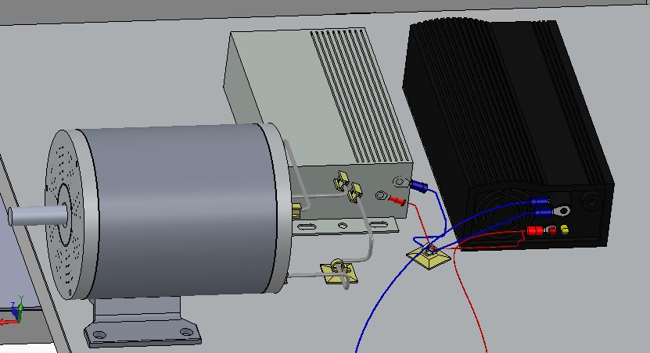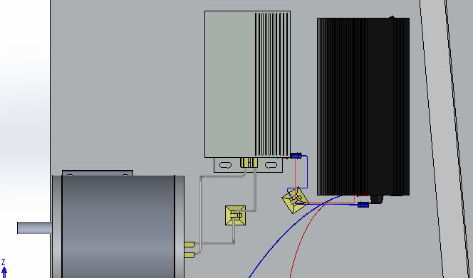

*Figure: Placement and Wiring of Components*

## Description of Electric Drive Train

* + Equipment selection for the drive train of the Autonomous Vehicle, have rigorously researched on the possible design aspects of the prototype incorporating an Electric Vehicle, and have performed simulations for the circuits to test their performance with respect to our requirements.

## Selection of Motor:

## The determination of Engines is the essential worry in the improvement of the electric vehicle, with contemplations to adjust to ideal battery prerequisites and have the option to create sufficient force for the activity of the vehicle.

## The determination of Engine is finished for a Brushless-DC Engine, appraised 1000W.

## The street load estimations beneath approve the determination of the previously mentioned parts.

## Interpretation of Simulations:

## The expected power is around 900 W which is reasonable for slight height, there is some vulnerability that subsequent to assembling the mass of the vehicle increments; thus, we chose to pick an engine with 1000 W of force. We picked a Brushless DC engine since it enjoys a few benefits. Some of them are:

## Electric engine can make up for gear-shift force unsettling influences from ICE to upgrade driver solace

## Gives heaps of low-end force (steady Speed Force bend)

## Empowers more elevated level of vehicle control adaptability.

## Description of 1000 W BLDC Motor:

* + After performing the above simulations, the team decided to purchase a 1000 W BLDC motor with chain drive. The specifications for the motor are provided below:

|  |  |  |  |
| --- | --- | --- | --- |
| **Motor Characteristics** |  | **Rated Value** |  |
| Model |  | MY1020 High Speed BLDC |  |
| Maximum Output Power | 1000 W | | |
| Rated Voltage | 48 V DC | | |
| Rated Speed | 4000 r/min (max 5400r/min) | | |
| Weight | 3.5 kg – 4.0 kg | | |
| Diameter | 95 mm | | |
| Applicable Controller | 48V 1000W Brushless Controller | | |
| Application Chain | T8F Sprocket/Chain | | |
| Maximum Current | 20 A | | |
| Rated Torque | 4 N/m | | |
| Sensor | Hall Sensor | | |

*Table: BLDC Motor Specifications*

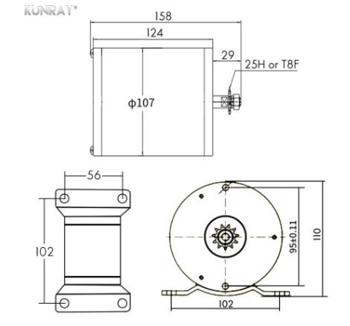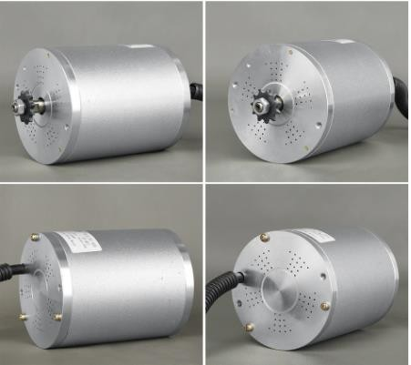

## Design of Electronic Speed Controller:

* + The Electronic Speed controller is designed corresponding to the motor power requirements. The motor selected earlier is consuming 1000W power and this is operated at 48V
  + The Design of custom ESC is explored and a suitable ESC for the motor requirements is also purchased

## Details of BLDC Motor Controller:

## BLDC engine represents brushless DC engine which doesn't depend on brushes for compensation.

## Because of the shortfall of brushes BLDC engines can work with greatest proficiency since the shortfall of brushes assuages it from erosions and other related shortcoming.

## To drive this engine, we really want a 3-stage span, its fundamental components are the 6 MOSFETs. The sensored BLDC engine has 3 Lobby Impact sensors (A, B and C) to detect rotor position.

* + The schematic for the design is provided below:

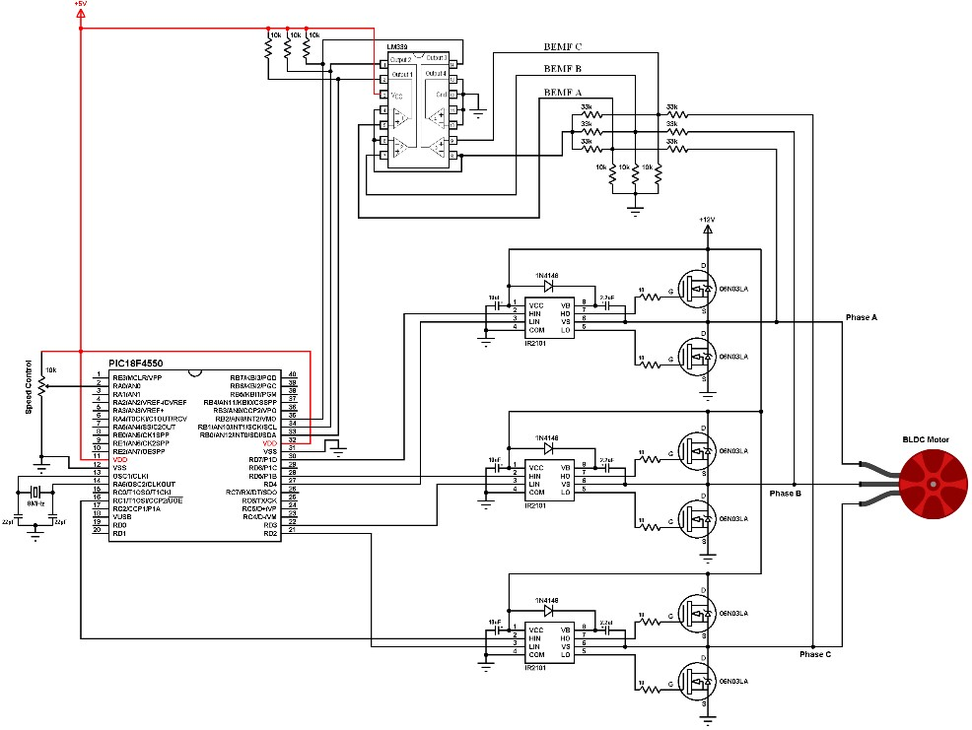

*Figure: Proteus Schematic for ESC motor controller*

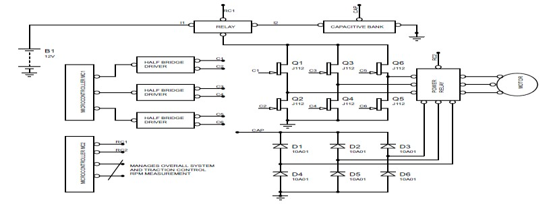

*Figure: Block Diagram for ESC*

|  |  |
| --- | --- |
| **ESC Characteristics** | Rated Value |
| Rated Voltage Range | 48V |
| Rated Power option | 1000W |
| Max Current option | 22A-40A (Tacitly35A) |
| Low-Voltage Protection Point | 20V/31V/42V (customizable) |
| Motor Phase Angle | 60°/120° |

*Table: ESC Specifications*

## Steering Motor Selection:

* + The requirements of the Stepper motor are RPM: 120 ~ 140 r/min. and Torque: 6Nm.
  + The response time of 0.6 sec is achieved against 100 rpm, which is under the threshold of 1.0 sec

## Stepper Motor Selection:

* + Use gear with low torque, high RPM stepper to achieve required specs.
  + The motor selected for this scenario is NEMA 23, the torque curve is shown below:

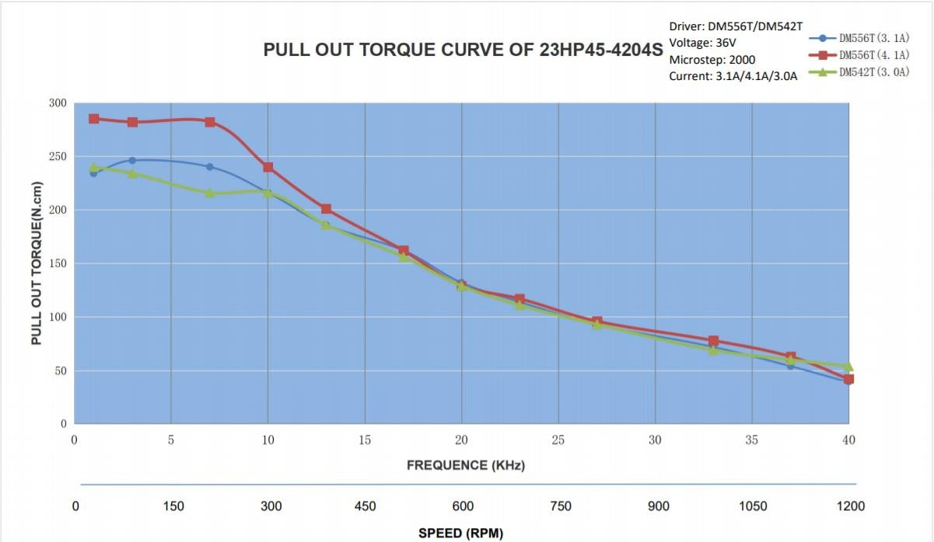

*Figure: NEMA 23 Torque Speed Graph*

* + From the graph above the Torque rapidly decreases as RPM increases.
  + Assuming no Mechanical Losses, the maximum calculated ratio = 900 / 140 = 6.42 ~ 6
  + (Where 900 rpm is the speed of the motor).
  + 6 ratio maximum torque at 140 rpm point yields 6 * 0.5 = 3 Nm
  + The other solution is to use maximum torque of 8Nm

*Figure 27: MEMA 34 Torque frequency curve*

* + 𝑅𝑃𝑀 = 𝑃𝑃𝑆 ∗ 1.8 = 600 ∗ 1.8 = 180 𝑟𝑝𝑚 > 140 𝑟𝑝𝑚

6 6

* + So useful operation points are bounded by the area till 600 pps on the above graph.

## Controller Selection:

* + An encoder coupled closed loop stepper motor is required to ensure steps with maximum accuracy.
  + Encoder is required to keep track of manual steering operation.
  + Closed loop controller eliminates backlash from steering mechanics till the motor holding torque of 8 Nm.
  + The controller has configurable steps up to 40,000.

|  |  |
| --- | --- |
| **Stepper Motor Characteristics** | **Value** |
| Type | Closed Loop Stepper Motor |
| Model | NEMA 34 8.0Nm |
| Step angle (degrees) | 1.8 degree |
| Current / Phase | 6 A |
| Holding Torque | 8 Nm |
| Shaft diameter | 14 mm |
| Motor body length | 136 mm |
| Nominal Voltage | 60 V |
| Phase Inductance | 5.2 mH |
| Phase Resistance | 0.95  |
| Rotor Inertia | 2800 g.cm2 |
| Type | Hybrid |
| Encoder resolution | 1000 |
| Display |  |

*Table: Stepper Motor Specifications*

* + In order to operate the Stepper Motor at 60 V, we require a High-Power Boost converter to step up the voltage and provide input voltage of 60V to the motor. The specifications are listed below:

|  |  |
| --- | --- |
| **Boost Converter Characteristics** | **Value** |
| Model | High Power Boost converter |
| Power | 1200W W |
| Current | 20 A DC |
| Step up Voltage | 60 V |
| Input Voltage | 48 V (battery) |
| Output Current | 20 A |
| Weight | 262 g |
| Display |  |

*Table: Boost Converter Specifications*

## Car Electrical Systems:

|  |  |
| --- | --- |
| **Headlights** | **Value** |
| Type | C6 Led Headlight Bulbs |
| Lumens | 3800 lm/bulb, 7600lm/pair |
| Power | 36W/bulb 72W/set |
| Rated Voltage | 12 V |
| Waterproof Rate | IP65 (waterproof) |
| Display |  |

*Table: Headlights Specifications*

|  |  |
| --- | --- |
| **Turn Indicator** | **Value** |
| Type | LED indicator |
| Power | 2 – 3 W |
| Rated Voltage | 12 V |
| Display | https://tse2.mm.bing.net/th?id=OIP.NRMa-n8A60noOstGzo-FQQHaEM&pid=Api&P=0&w=294&h=167 |

*Table: Indicator Specifications*

|  |  |
| --- | --- |
| **Horn** | **Value** |
| Type | CG 125 Horn |
| Power | 18 W |
| Rated Voltage | 12 V |
| Display | https://tse1.mm.bing.net/th?id=OIP.iOvWA5dXEY-hFWfrHwejngHaFW&pid=Api&P=0&w=236&h=172 |

*Table: Horn Specifications*

|  |  |
| --- | --- |
| **Fault Buzzer** | **Value** |
| Type | Arduino Active Buzzer |
| Interface | I/O Interface of SCM |
| Rated Voltage | 5 V |
| Display |  |

*Table: Fault Buzzer Specifications*

* + From above selections we need a 12V Bus to power our car electrical Systems.

|  |  |
| --- | --- |
| **Buck Converter** | **Value** |
| Type | Step down module |
| Power | 200 W |
| Rated Current | 15 A |
| Input Voltage | 8-55V |
| Output Voltage | 1-36V |
| Operating Frequency | 180 KHz |
| Conversion Efficiency | 94% |
| Display |  |

*Table: Buck Converter Specifications*

# Steering System

Our uniquely designed steering system has following features:

* + - Light weight.
    - Very less steering effort required.
    - Mechanical links are retained due to redundancy to ensure the safety of driver/passenger.
    - Override feature.

# Braking System

# o as our slowing mechanism is for low weight Vehicle, extremely less power is expected for slowing down.

# o Mechanical connections of pressure driven brakes Framework are held for wellbeing.

# o Servo engine is utilized for robotization and control of slowing down.

# o Our vehicle establishes of various subsystems, regulator various connection points for example Sensors and actuators.

# o These subsystems are associated with our fundamental ECU (Nvidia AGX Xavier) through CAN-Transport.

# o Every subsystem comprises of ATMEGA328p microcontroller, alongside significant sensors all through the vehicle.

# .

Can bus topology

* + - For CAN BUS we are using MCP2515 CAN controller, connected to our microcontroller through SPI interface.
    - The structure of the CAN-BUS is CAT6 Ethernet cable.
    - The components for CAN-BUS are detailed below.

|  |  |  |  |
| --- | --- | --- | --- |
| **Component** | **Type** | **Description** | **Model** |
| Arduino UNO | Micro controller | The Arduino will be connected to each sensor to collect data and send it to Xavier. | Arduino UNO R3 - SMD Buy Online in karachi, Pakistan |

|  |  |  |  |
| --- | --- | --- | --- |
| CAN-BUS shield | CAN-  Transceiver integrated | The CAN-BUS Shield provides Arduino with CAN-BUS capabilities and allows it to poll the ECU for sensor information | E:\NUST\Semester 6\LCS\c1c9db39-1436-4b78-9119-96f0b35eeea2.jpg |

*Figure: Benchmark Performance of MYNT Eye S camera (depth sensing)*

# ▪ The sound system camera is combined with a six pivot IMU joined with outline synchronization which give exactness at short of what one millisecond. Complete bundle with SDK is easy to incorporate furnishing simple turn of events and fast reconciliation with the profundity information made through the EYE S sensor.

# Other Sensors:

|  |  |  |  |
| --- | --- | --- | --- |
| **Sensor Name** | **Sensor Type** | **Description** | **Sensor Model** |
| VL53L0X Time-of- Flight Distance Sensor | Ranging Sensor | Short range (5m), high precision ranging sensor |  |